**Multiple Currency (Multi currency**) **in Salesforce:**

Multicurrency in Salesforce is like having a calculator that can work with different types of money. Imagine you're running a business, and you sell your products or services to people all around the world. These customers might pay you in different currencies like US Dollars, Euros, or Japanese Yen.

With multicurrency in Salesforce, you can keep track of all these different currencies in one place. It helps you do things like:

1. **Pricing**: You can set prices for your products or services in different currencies. So, if you're selling a product for $100 in the US, you can also sell it for €90 in Europe or ¥10,000 in Japan.
2. **Reporting**: Salesforce can automatically convert all the different currencies into a common one (like US Dollars) for your financial reports. This way, you can see how much money you're making overall, no matter what currency your customers use.
3. **Records**: You can store information about deals and transactions in their original currencies, making it easier to understand who paid how much in their own money

**How to enable Multiple Currency:**

1. Go to Setup and search for company information
2. Click on edit button
3. Check Activate Multiple Currencies (**Here make sure once activated, it cannot be disable**). 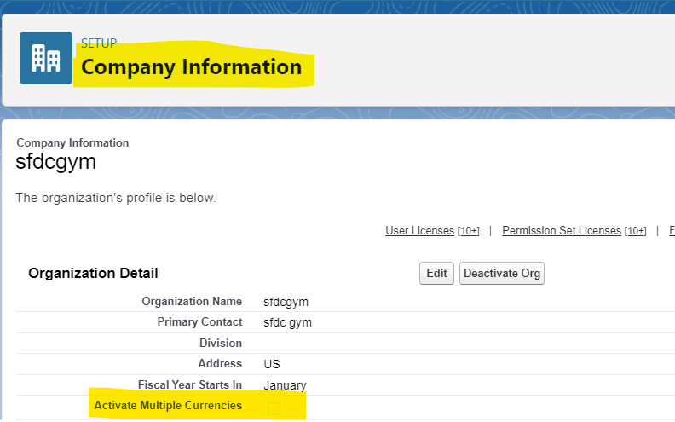
4. After that click on **Currency Setup** button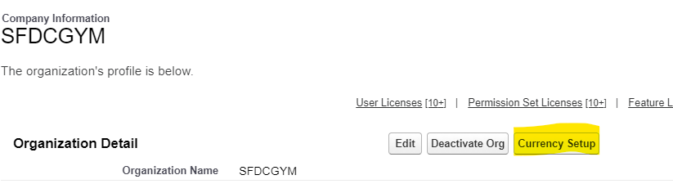
5. Click on new button and add the conversion rate and save the currency.

**Salesforce CPQ on Multiple Currency:**

When you enable Multiple Currencies in a Salesforce environment, Salesforce CPQ becomes capable of generating quotes and computing prices in the currencies you've activated. The Salesforce CPQ objects with management support can seamlessly operate with Salesforce's multi-currency functionality

**Interview Questions**

1. How does Salesforce CPQ handle currency conversion?
2. How can you generate quotes in a customer's preferred currency using Salesforce CPQ?